**INTRODUCTION:**

In the ever-evolving landscape of education, the integration of technology has become paramount to enhance or improve the effectiveness of the learning experience. This project emerges as a comprehensive solution designed to bridge the gap between students, parents, teachers, and administrators, fostering a more efficient and engaging educational ecosystem.

Additionally, it enables the implementation of automated attendance tracking systems. This not only saves time for teachers but also provides accurate and real-time attendance data, contributing to better monitoring of student engagement.

This project/application also implements advanced security measures, including user authentication and access controls. This helps protect sensitive information, and ensures that only authorized individuals have access to specific functionalities, which is crucial for maintaining data integrity and safeguarding privacy.

**PROJECT OVERVIEW:**

This project **(MyAIR)** is made in Python using a GUI (Graphical User Interface) called **Tkinter.** It is designed to make the users do things in an easy and time saving manner.

The project is basically a **School Managing window/software** where teachers can add details of students by logging in with their usernames and passwords, insert the marks of any particular student and mark the attendance of the students. The data will be stored in the form of tables in the back end (MySQL).

On the other hand students/parents are given their particular usernames and passwords to log in. Through this, they can check their or their children’s academic results (in the form of bar graphs) of the exams through the year that are held on a regular interval.

They can also check for the regular updates, which are available on the school’s website, by clicking on the “INFORMATION” tab once they are logged in.

By clicking on the “ATTENDANCE” tab, they can know their percentage of absence/presence since the beginning of the academic year in the form of a pie chart.

**PURPOSE OF THE PROJECT:**

Our purpose is clear: to empower educational institutions with a robust, in a user-friendly way that serves as a catalyst for positive change. From real-time communication between teachers and parents/students to streamlined administrative processes, we aim to be a versatile companion in the educational journey.

By offering immediate access to academic information such as grades, attendance records, and upcoming events, the software fosters transparency and accountability.

Crucially, this project encourages parental involvement by granting parents insight into their child's academic journey and enabling direct communication with teachers.

**OUTPUT:**

Screen1

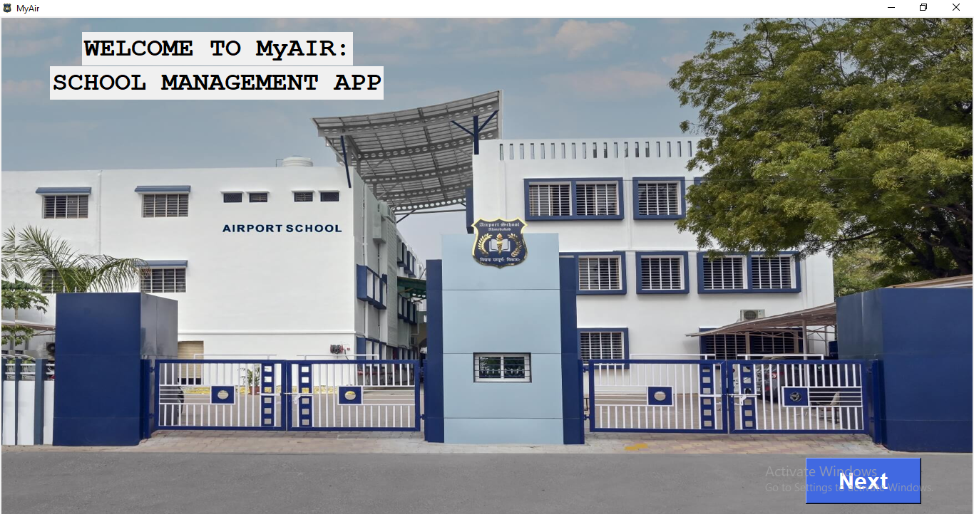

Screen2

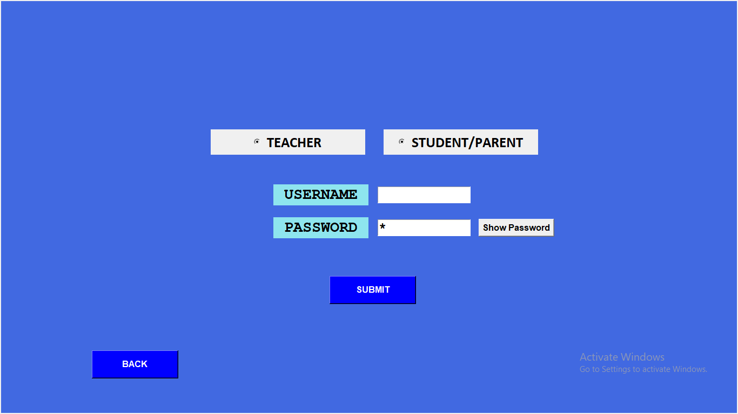

**FOR TEACHER/ADMIN**

Screen3

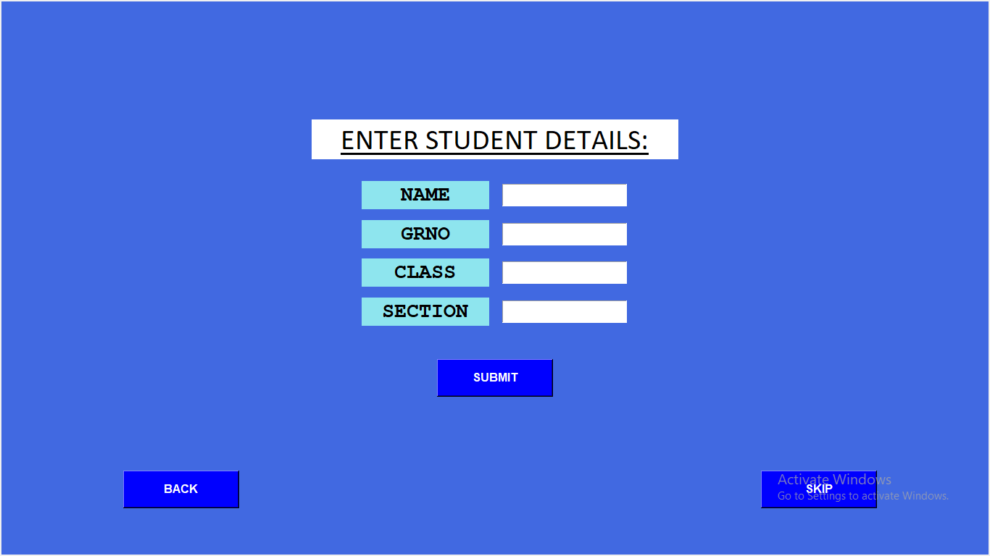

Screen5

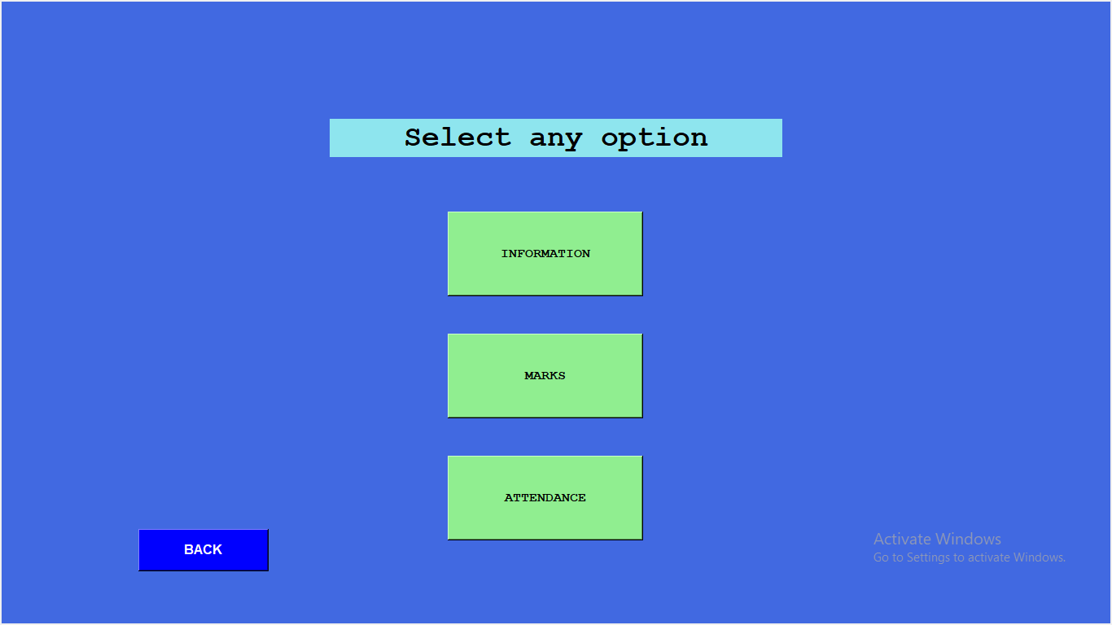

Screen13(Information)

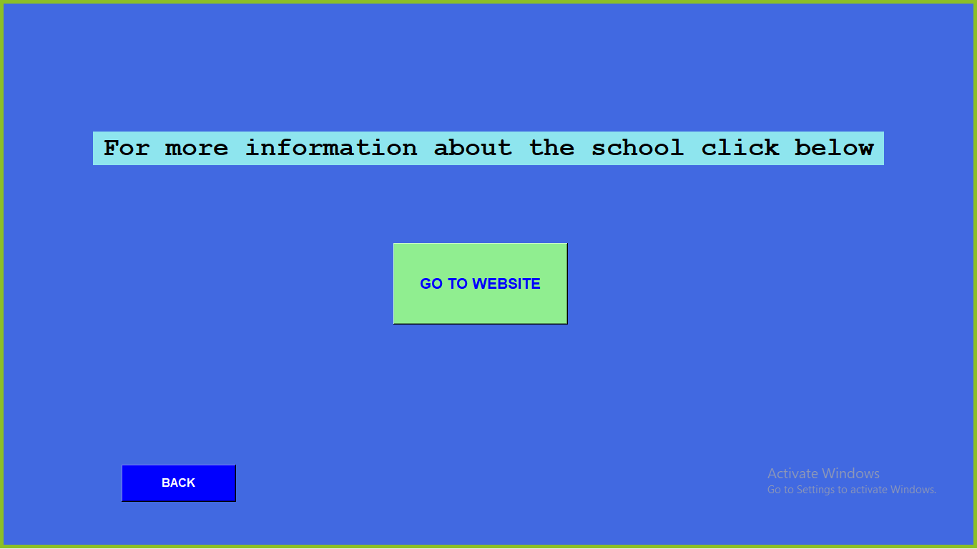

Screen6(Marks)

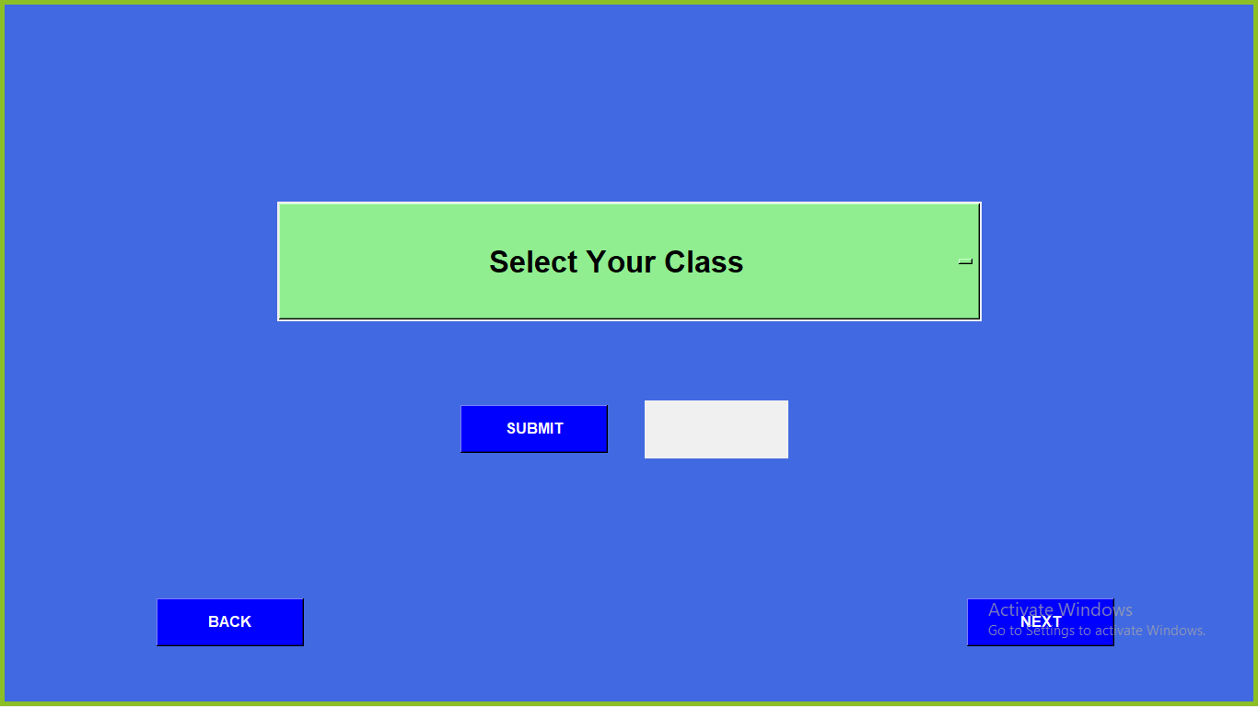

Screen12(Attendance)

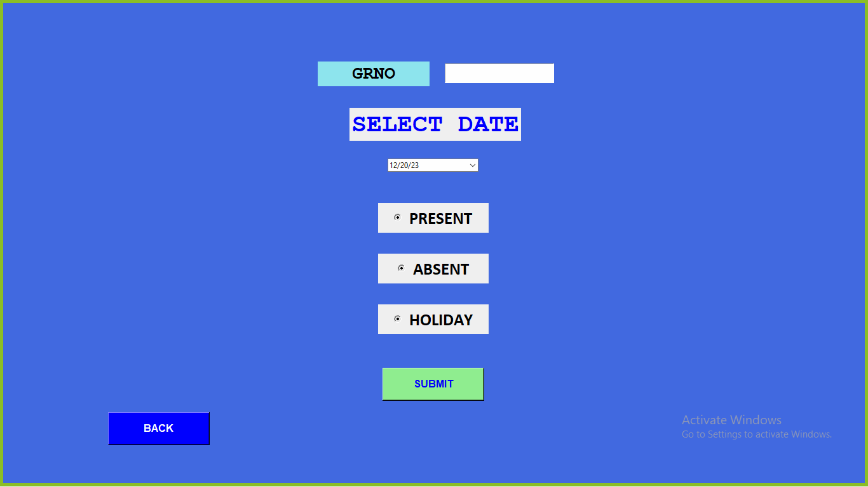

Screen7

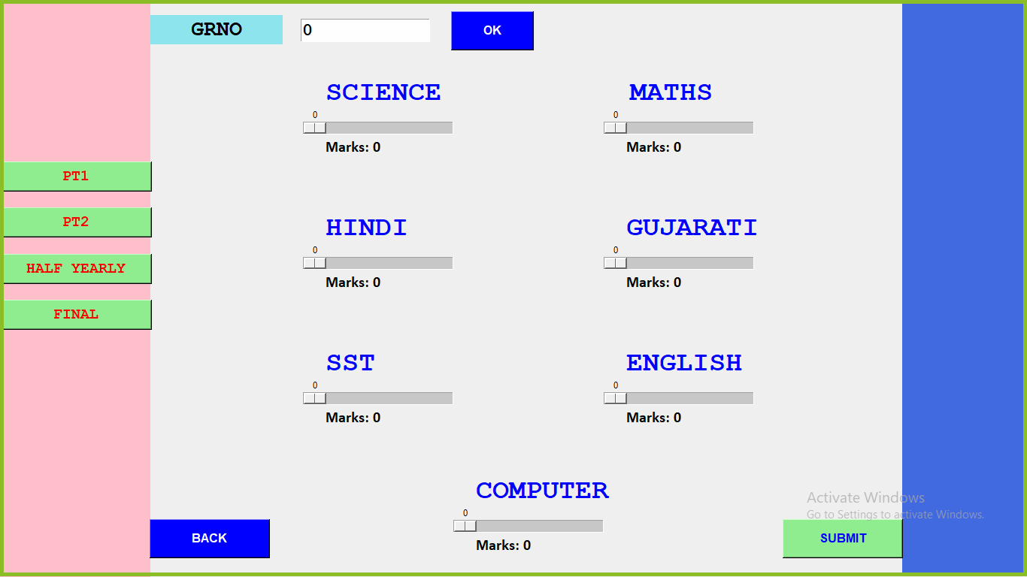

Screen8

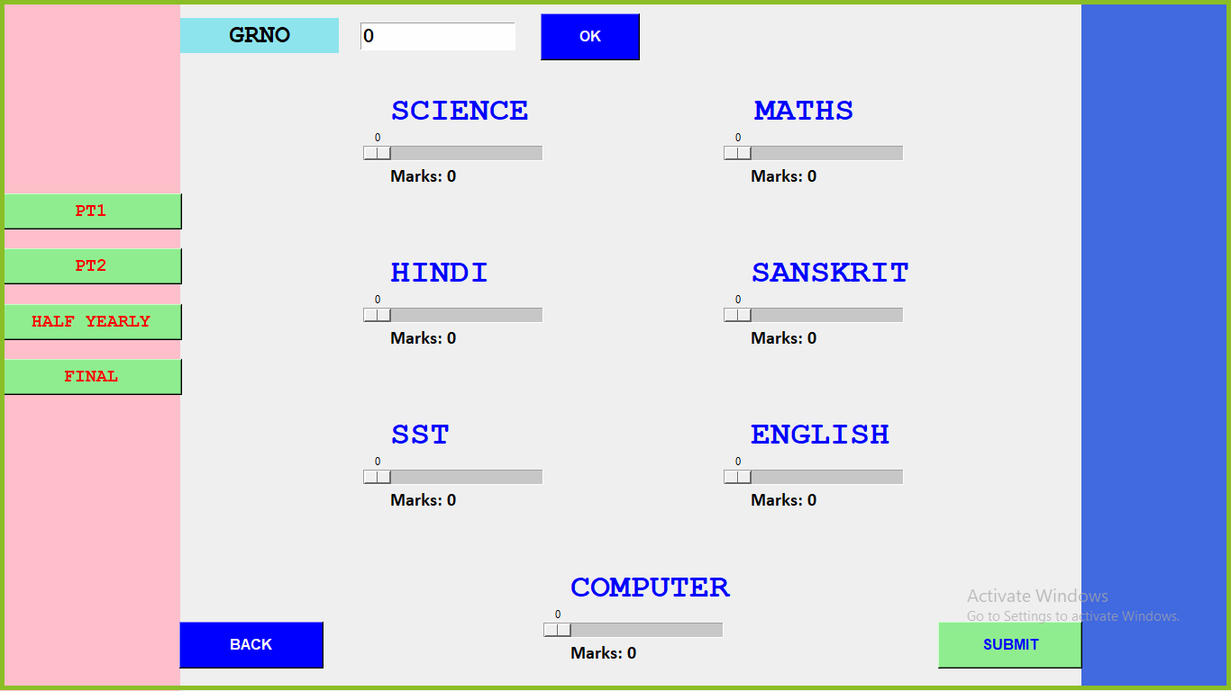

Screen9

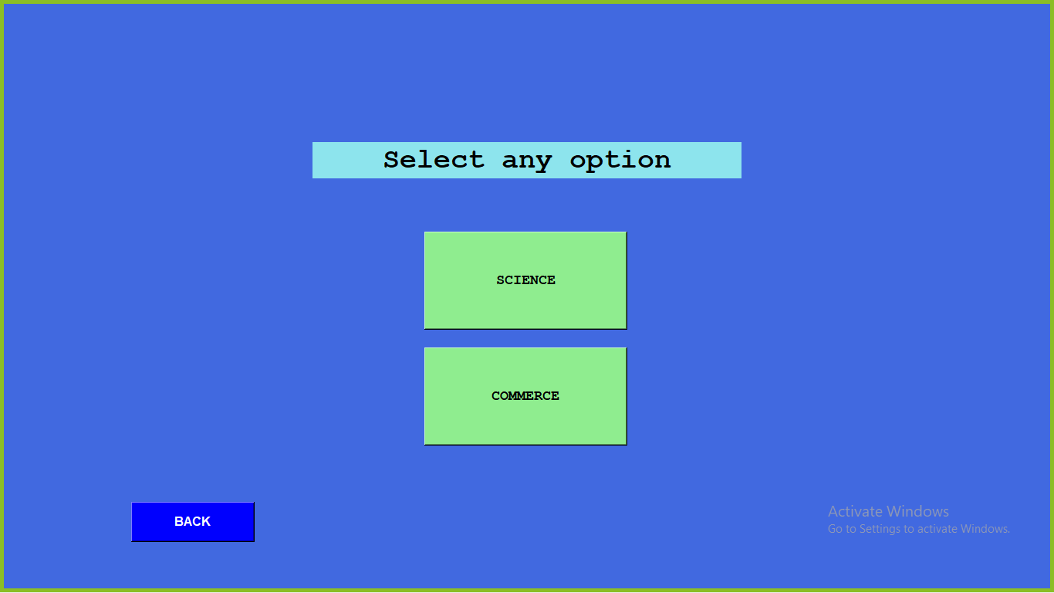

Screen10

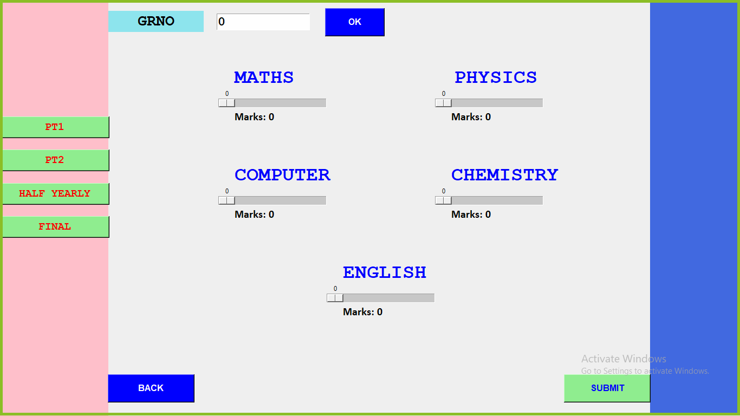

Screen11

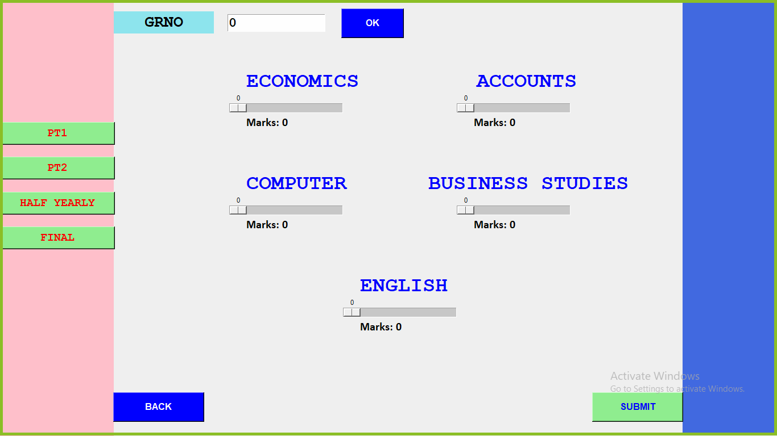

**FOR STUDENT/PARENT**

Screen4

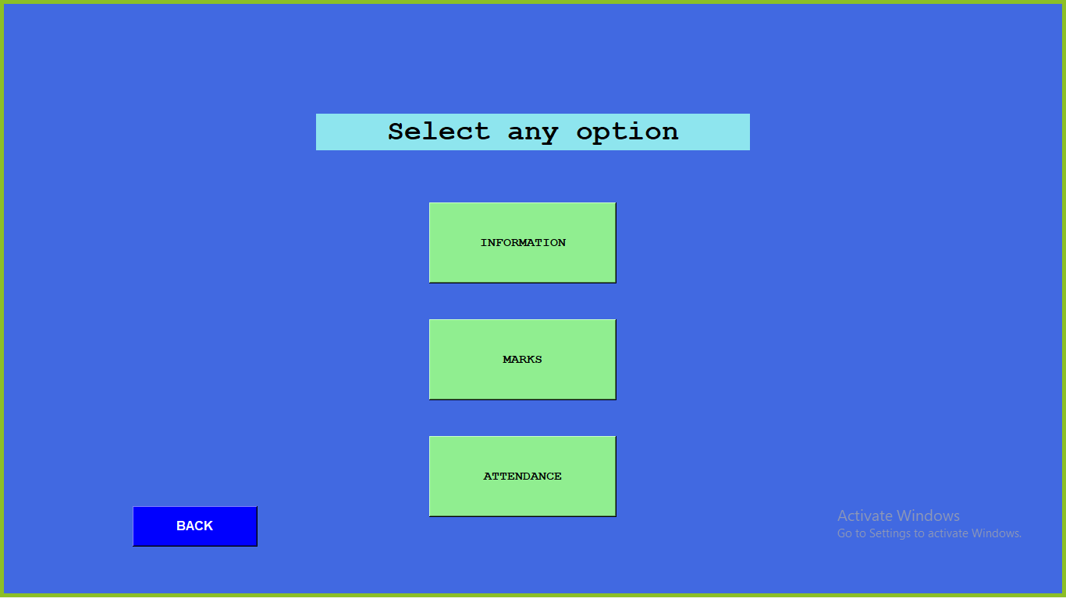

Screen21(Information)



Screen14(Marks)

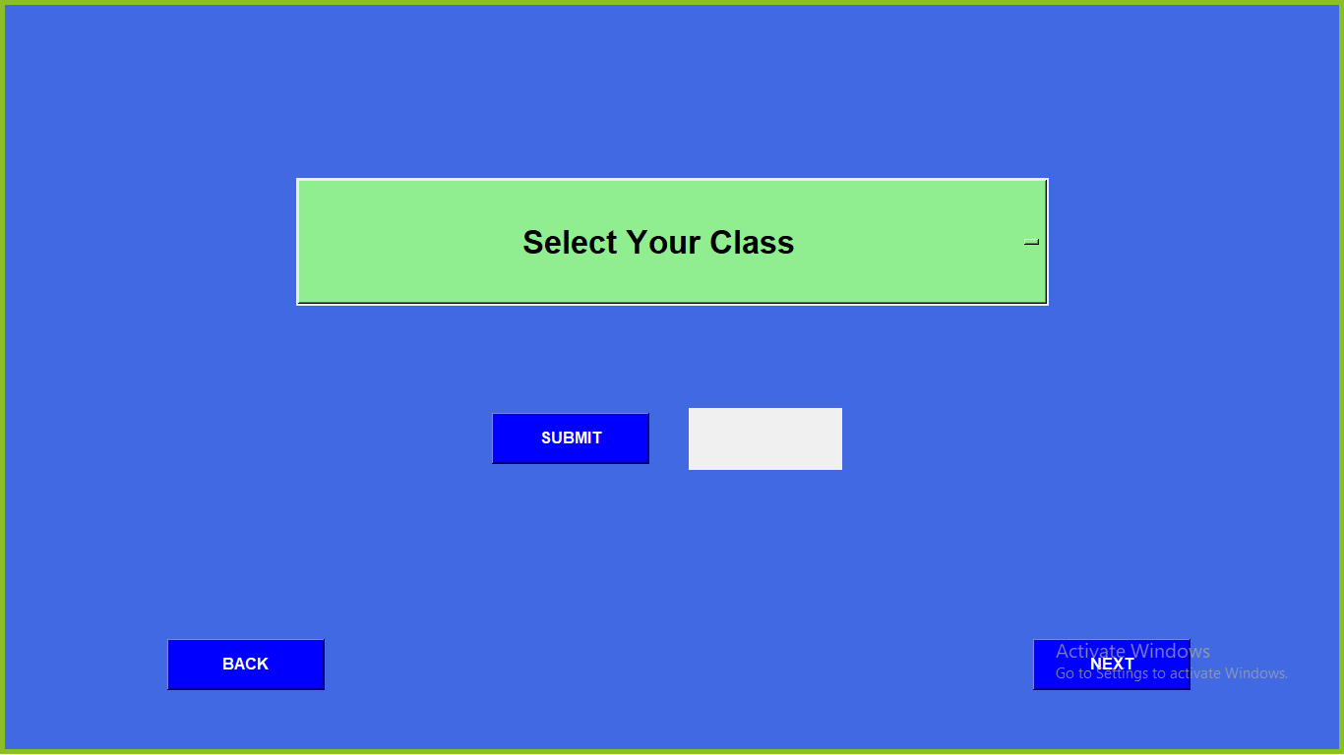

Screen20(Attendance)((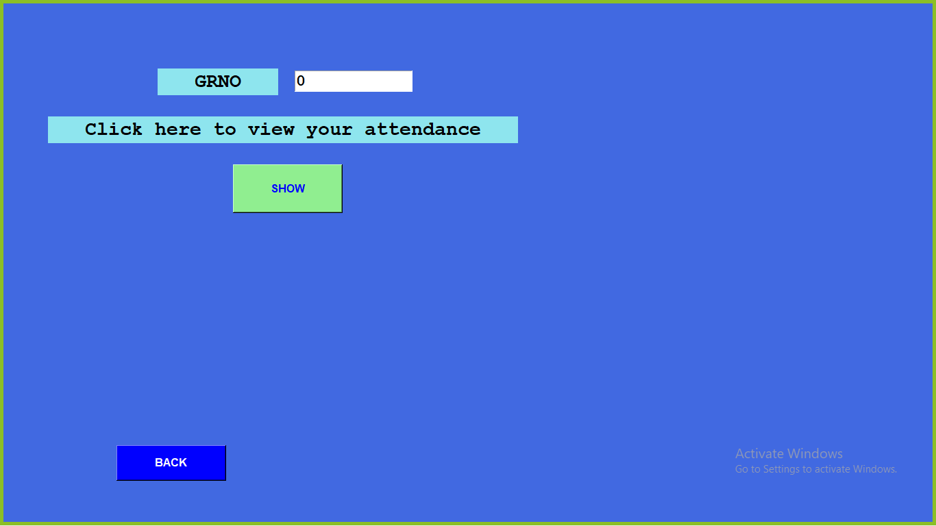

Screen15

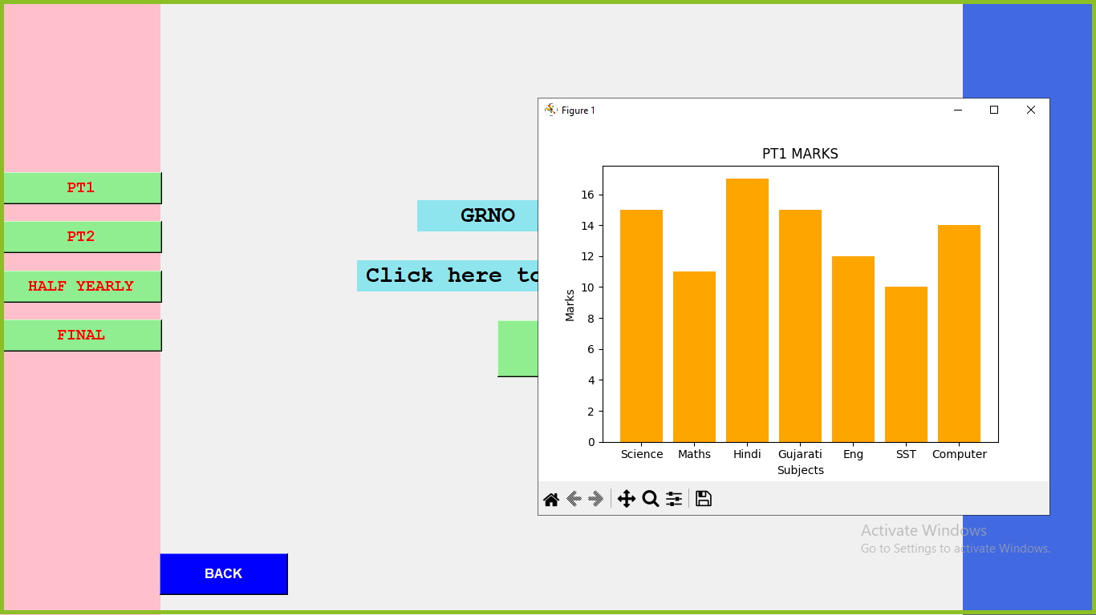

Screen20

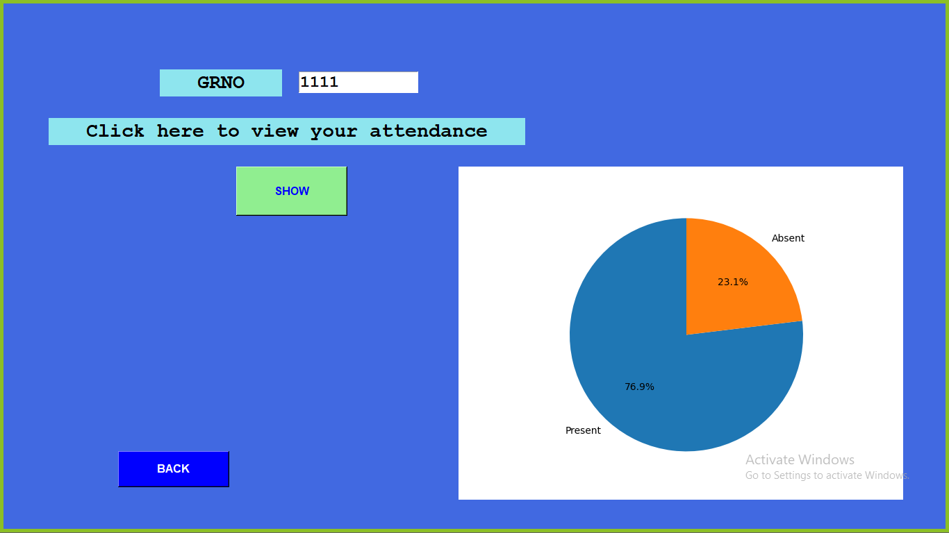

**MySQL**

